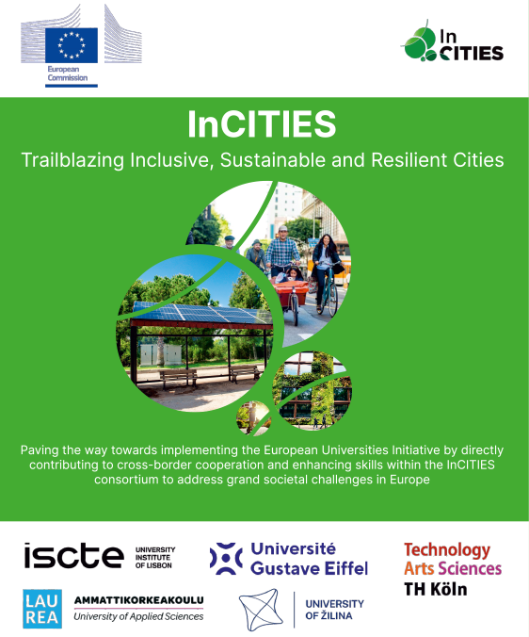

**Join the Scientific InCITIES Cafés**

As a follow up of the InCITIES WP2 Task 2.1 Knowledge Hubs building, the project team propose a series of webinars call **Scientific Cafés** to develop common knowledge between the partners researchers.

These **Scientific Cafés** were setup to topic groups, namely: *Questioning urban transition and vulnerability, inclusion, and health in the city*; *Sustainable and resilient city and digital transition*; *Mobility*; *Energy*; and *Nature in the City*.

During these webinars, researchers are welcome to present their work in order to share their results, scientific approach or methods in order to foster the possible collaboration between the research teams on collaborative projects, potential publications or co supervision of students.

The **Scientific Cafés** are forecasted to be held between February and the end of April 2024 on a 90 minutes format with 3 or 4 presenters (15 minutes to presentation and 5 minutes for questions from the audience) from 12h30 to 14h00 CET (or from 12h00 to 13h30 CET).

The aim is to have up to 10 webinars across all the above-mentioned thematic HUBs; these webinars will be recorded and available for replay on the InCITIES web site.

If you have any question please contact:

[Claude.marin-lamellet@univ-eiffel.fr](mailto:Claude.marin-lamellet@univ-eiffel.fr)

[yannick.cornet@uniza.sk](mailto:yannick.cornet@uniza.sk)

[Pedro.Manuel.Antao@iscte-iul.pt](mailto:Pedro.Manuel.Antao@iscte-iul.pt)